1. If your are doing **groupby**  then if after separating based on provided key, the indices in each group will be similar of the original one.
2. If you are concating two or more DF then the concated DF will retain the indecies of the original DF’s

Ex:

df = pd.concat([india_weather, us_weather])

df

output:

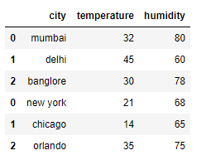

To have continuous index use ignore_index = True;

Ex:

df = pd.concat([india_weather, us_weather], ignore_index=True)

df

output:

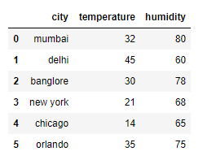

1. loc() & iloc():

If you are giving custom index on your DF, then loc returns value based on indices and iloc returns value based on row no(starting from 0).

And if you are not providing custom index then both loc and iloc returns value based on row no.